**MP3 readme**

Name: Sumit Patil

Date: 11/24/2013

To Run

test_mp3.bat located in test folder.

**Project description:**

Project loads the data from MySQL database in to the application and provides user with following options:

* To load the Database Data into the application
* To add a new Order File to the Database.
* Retrieve (view) or Delete any Employee by PrimaryKey.
* Retrieve (view) or Delete any Customer by PrimaryKey.
* view all Employees
* view all Customers
* View all orders

MainDriver class has the main method and is used to launch the application.

Test cases are written to cover the positive,negative and exception behavior of the

application.

**Installation, compile and run-time requirements:**

**Installation requirements**: MySQL Workbench 6.0 Build 6.0.7.11215

IDE: Eclipse

IDEVersion: Kelpler Version

Java JDK 7 version

**Compile time requirements**: Jar required: opencsv-2.4jar

**Run time requirements for batch file**: Runnable file requires the MySQL database instance to be created for BIRT sample database scripts found at [http://www.eclipse.org/birt/phoenix/db/ - mysql](http://www.eclipse.org/birt/phoenix/db/%20-%20mysql).

Connect to database using below credentials:

**Database Url** = "jdbc:mysql://localhost:3306/MP2";

**User Name** = "root";

**Password** = "password";

**User guide information on the dialogs:**

Run the MainDriver class in iit.itm.pru.mp2.driver package and verify that console window is opened with below options:

Main Menu:

1. Load the Database into the application

2. [Add a new Order File to the Database](Add%20a%20new%20Order%20File%20to%20the%20Database)

3. Retrieve (view) or Delete any Employee by PrimaryKey

4. Retrieve (view) or Delete any Customer by PrimaryKey

5. View all Employees

6. View all Customers

7. View all Orders

**Load database in to application:**

Enter “1” and press enter to load a database into the application.

Database should be successfully loaded in to the application and below message should be displayed.

“Database loaded into application successfully !”

E**rror message** is thrown when User enters invalid username, password or URL.

**Error message** is displayed when user selects option 1 and the required database does not exist.

Main menu is displayed after database is loaded successfully.

**Add a new Order File to the Database**

Enter “2” and press enter to add a new order record.

Below message is displayed once enter is pressed.

” Enter order number,order date, required date, shipped date, status, comments, customer number

Enter date in format 'yyyy-mm-dd'”

Give all the above details each in newline and press enter

Record should be inserted successfully and below message should be displayed.

“Record is inserted into Order table!”

Error message “Some ParseException Occured during Order record Insert !!” should be displayed when user attempts to insert invalid data in to order table.

Main menu is displayed after record is inserted successfully.

**Retrieve (view) or Delete any Employee by PrimaryKey**

Enter “3” from main menu and press enter to retrieve or delete an employee record.

Submenu with below options is displayed:

1. View Employee by Employee Number

2. Delete Employee by Employee Number

**View Employee record:**

* Enter 1 and press enter to view details of employee record.
* Message “Enter the Employee Number to view details” is displayed.
* Enter valid employee number and press enter.
* Employee details are displayed.
* Message “No employee with the given ID” is displayed when user enters invalid employee ID.
* Main Menu is displayed once the employee details are printed/above message is displayed for invalid entry.

**Delete Employee record:**

* Enter “2” and press enter to delete details of employee record.
* Message “Enter the Employee Number to delete from database” is displayed.
* Enter valid employee number and press enter.
* Employee details are deleted.
* Message “No employee with the given ID” is displayed when user enters invalid employee ID.
* Main Menu is displayed once the employee details are deleted/above message is displayed for invalid entry.

**Retrieve (view) or Delete any Customer by PrimaryKey**

Enter “4” from main menu and press enter to retrieve or delete an Customer record.

Submenu with below options is displayed:

1. View Customer details by Customer Number

2. Delete Customer by Customer Number

**View Customer record:**

* Enter 1 from submenu and press enter to view details of Customer record.
* Message “Enter the Customer Number to view details” is displayed.
* Enter valid Customer number and press enter.
* Customer details are displayed.
* Message “No Customer with the given ID” is displayed when user enters invalid Customer ID.
* Main Menu is displayed once the Customer details are printed/above message is displayed for invalid entry.

**Delete Customer record:**

* Enter “2” from the submenu and press enter to delete details of Customer record.
* Message “Enter the Customer Number to delete from database” is displayed.
* Enter valid Customer number and press enter.
* Customer details are deleted.
* Message “No Customer with the given ID” is displayed when user enters invalid Customer ID.
* Main Menu is displayed once the Customer details are deleted/above message is displayed for invalid entry.

**View all Employees**

Prior to view the employee details, database should be loaded in to application successfully.

* Once the database is loaded successfully, enter “5” from main menu and press enter to view the employee records.
* Message “First you will have to load the database into the application” is displayed when database is not loaded and user attempts to view the employee records.
* Main Menu is displayed once the employee details are printed.

**View all Customers**

Prior to view the Customer details, database should be loaded in to application successfully.

* Once the database is loaded successfully, enter “6” from main menu and press enter to view the Customer records.
* Message “First you will have to load the database into the application” is displayed when database is not loaded and user attempts to view the Customer records.
* Main Menu is displayed once the Customer details are printed.

**View all Orders**

Prior to view the Orders details, database should be loaded in to application successfully.

* Once the database is loaded successfully, enter “7” from main menu and press enter to view the Orders records.
* Message “First you will have to load the database into the application” is displayed when database is not loaded and user attempts to view the Orders records.
* Main Menu is displayed once the Orders details are printed.

**Development and testing insights with expected results:**

* The application handles all the possible exceptions where user can go wrong and allows the user to run the application without interruption.
* MainDriver is the class which contains the main method and from where the mp3 code execution of starts.
* We have defined customized exception “DatabaseConnectionException.java” which extends exception class.
* We have used try-catch to catch all the exceptions in the main method.
* The entire data loading from database is handled by CustomersDAO.java,EmployeesDAO.java,OrdersDAO.java. All these classes uses RetrieveAbstract.java class to retrieve data from database.
* The view/delete operations on customer and employee records are handled by RDEmployeeCustomerRecord.java class.
* Tests CustomerSqlTest.java, EmployeeSqlTest.java, OrdersSqlTest.java are designed to test all the positive, negative and exception functionality of the mp3 project requirements.

**Screen captures demonstrating all application capabilities:**

**Loading database in to application:**

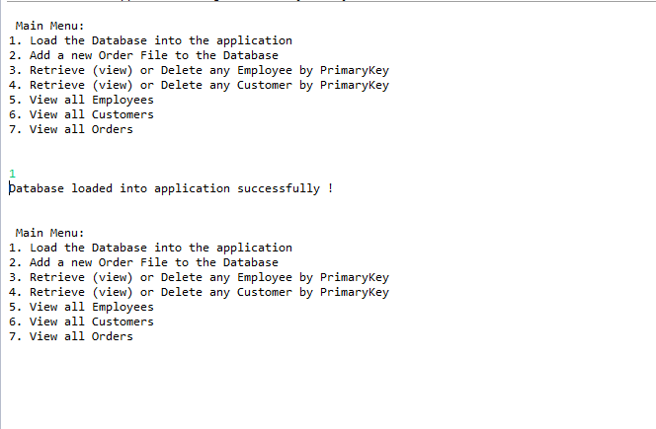

**Adding new Order record:**

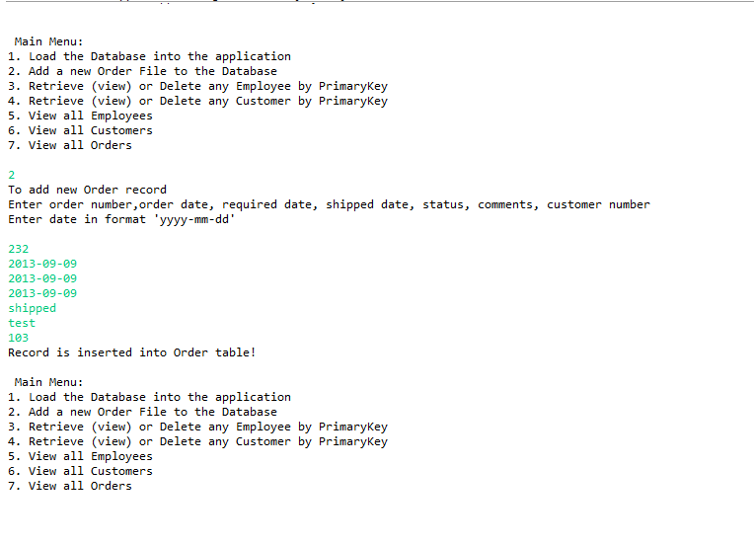

**View Employee data:**

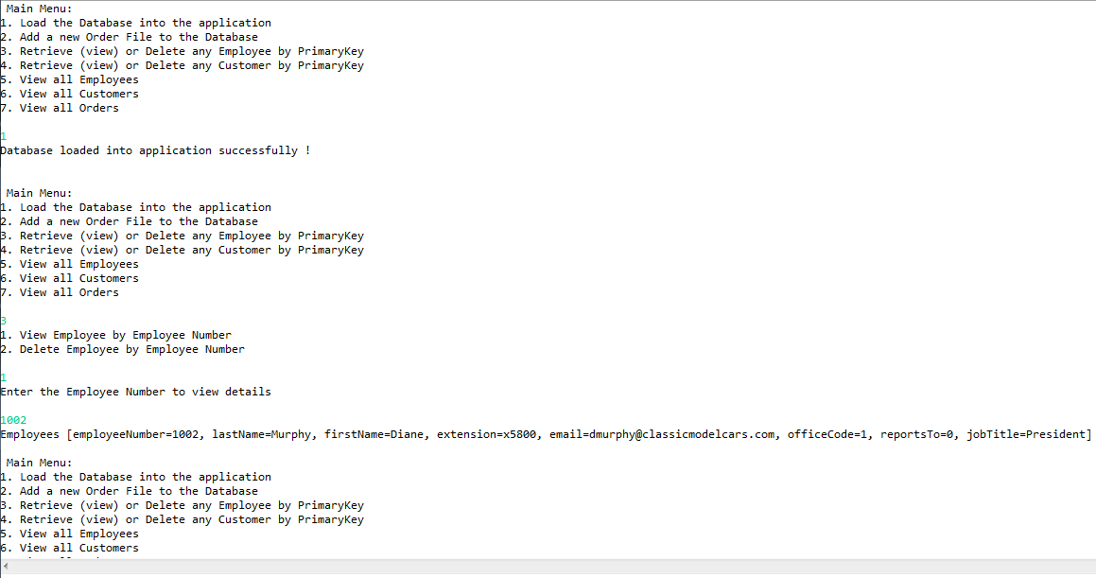

**Delete Employee data:**

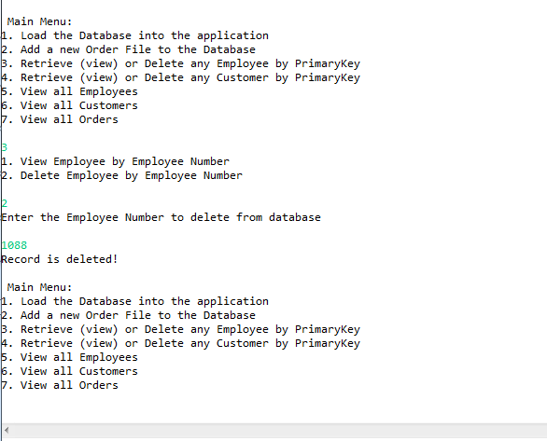

**View Customer Data:**

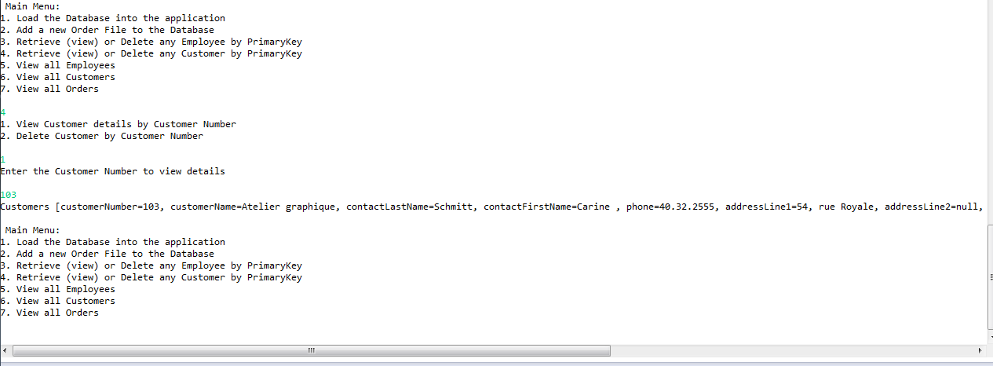

**Delete Customer Data:**

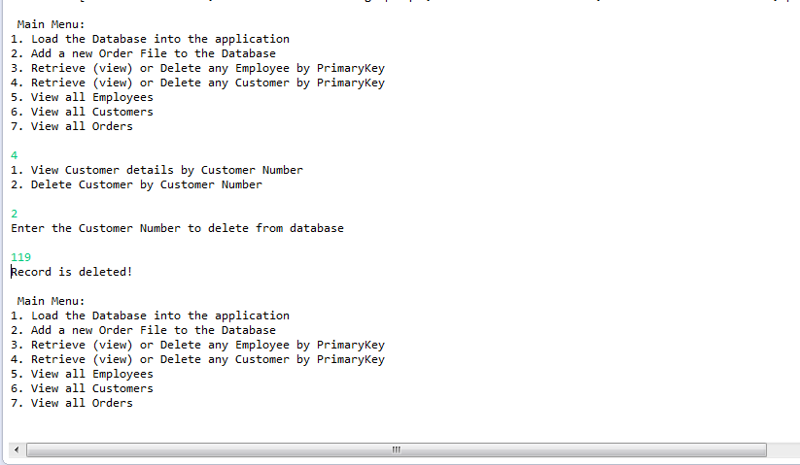

**View Employees Data:**

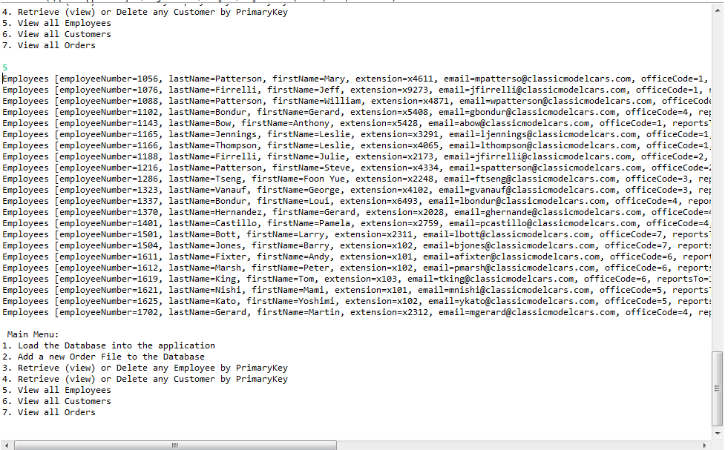

**View Customer Data:**

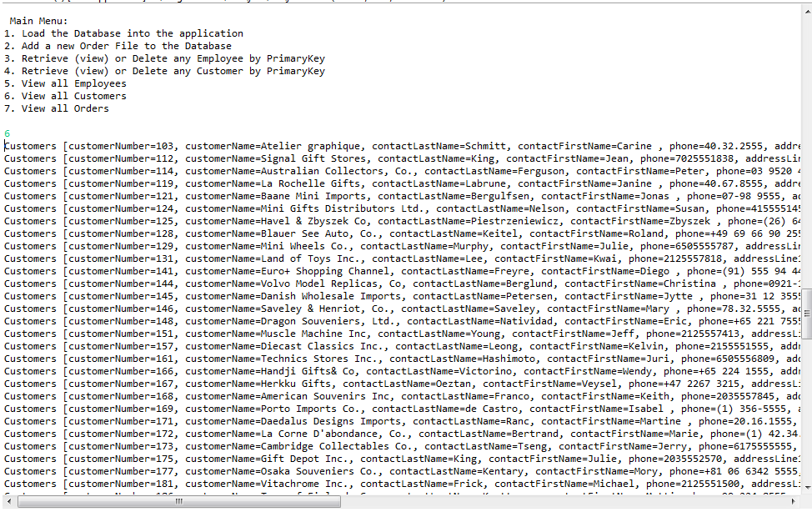

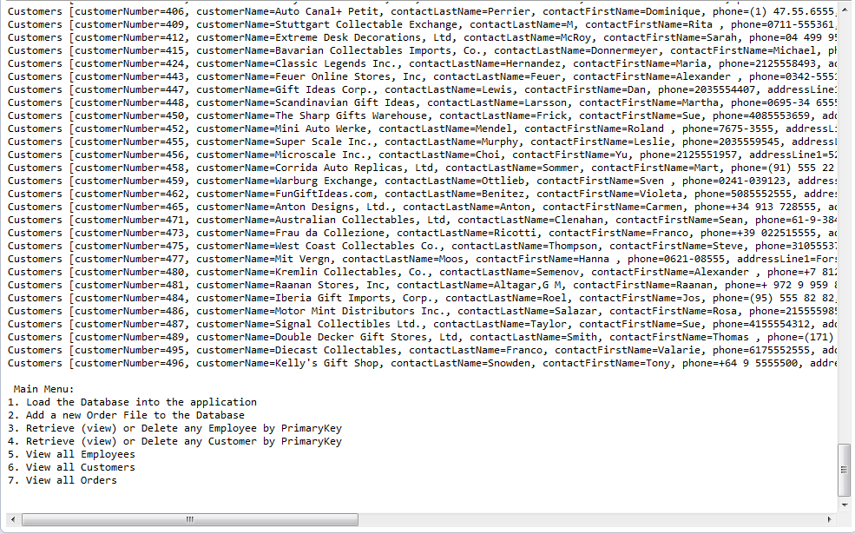

**View Orders Data:**

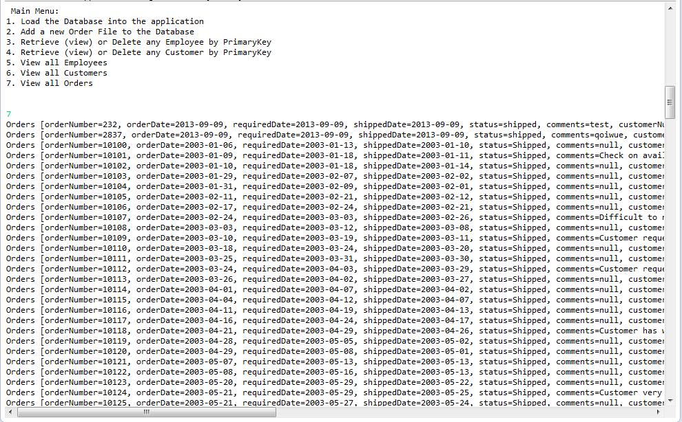

**User attempting to view customer,employee,orders records when database doesnot exist**

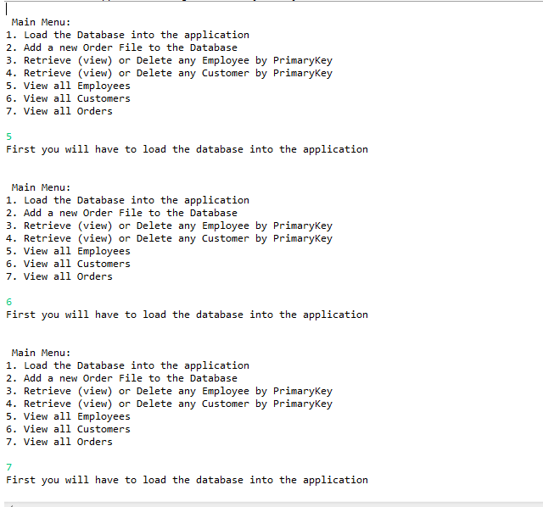

**Message when user enter invalid option in main menu:**

